##### <Staff> Create Product

**Use case diagram**

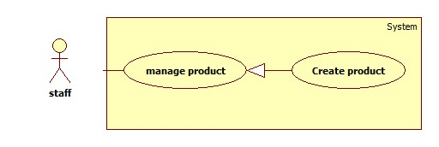

Figure: <Staff> Create Product

**Use case Specification**

|  |  |  |  |
| --- | --- | --- | --- |
| **USE CASE –** | | | |
| **Use Case No.** |  | **Use Case Version** | 2.0 |
| **Use Case Name** | Create Product | | |
| **Author** | Ha Chi Danh | | |
| **Date** | 30/05/2014 | **Priority** | Normal |
| **Actor:**   * Staff.   **Summary:**   * This use case allows staff to create product.   **Goal:**   * New product will be added to the database.   **Triggers:**   * Staff wants to create new product. * To input product manually, staff must do the following steps:   + Click “Quản lý sản phẩm” in the menu.   + Click “Tạo sản phẩm” button.   **Preconditions:**   * User must log in the system with staff role.   **Post Conditions:**   * **Success**: New product will be added to the database. * **Fail:** Show error message.   **Main Success Scenario:**   |  |  |  | | --- | --- | --- | | Step | Actor Action | System Response | | 1 | Click “Tạo sản phẩm” button. | Navigate to “Tạo sản phẩm” page which contains:   * Tên sản phẩm: textbox (min length: 5, max length: 50), required. * Tên Hãng: dropdown list. * Chi tiết: rich textbox. * “Thêm sản phẩm” button. * “Thêm hình ảnh” button * “Hủy” button. | | 2 | Enter information into text fields.  Click “Thêm sản phẩm” button to finish. [Alternative 1,2] | System will add product into database.  A new product will be displayed in list product page. Then, redirect to “Quản lý sản phẩm” page. [Exception 1, 2] |   **Alternative Scenario:**   |  |  |  | | --- | --- | --- | | Step | Actor Action | System Response | | 1 | Click on “Hủy” button to finish. | Product is not added. System will return back to “Quản lý sản phẩm” page. | | 2 | Session time out. | Display error message: “Bạn rời máy tính quá lâu, vui lòng đăng nhập lại để tiếp tục”.  Redirect to login page. |   **Exceptions:**   |  |  |  | | --- | --- | --- | | Step | Actor Action | System Response | | 1 | “Tên sản phẩm” is not in range [5, 50]. | Display error message: “Tên sản phẩm phải từ 5 đến 50 ký tự”. | | 2 | “Tên sản phẩm” is a blank. | Display error message: “Vui lòng nhập Tên sản phẩm”. |   **Relationships:** N/A  **Business Rules:**   * Staff clicks on “thêm sản phẩm” button. * System will save new product into database. | | | |

##### <Staff> Update Product

**Use case diagram**

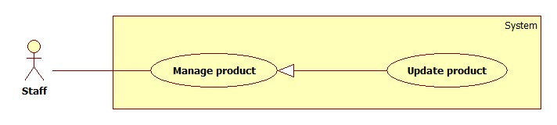

Figure: <Staff> Update Product

**Use case Specification**

|  |  |  |  |
| --- | --- | --- | --- |
| **USE CASE –** | | | |
| **Use Case No.** |  | **Use Case Version** |  |
| **Use Case Name** | Update Product | | |
| **Author** | Ha Chi Danh | | |
| **Date** | 30/05/2014 | **Priority** | Normal |
| **Actor:**   * Staff.   **Summary:**   * This use case allows staff to update product information.   **Goal:**   * New information will be updated to selected product.   **Triggers:**   * Staff wants to change product information. * To change product information, staff must do the following steps:   + Choose “Quản lý sản phẩm” in sidebar menu.   + Click at product.   + Change information.   + Click “Cập nhật” button to save new data to database.   **Preconditions:**   * User must log in the system with staff role. * There is at least one product in the database.   **Post Conditions:**   * **Success**: New information will be updated to selected product. * **Fail:** Show error message.   **Main Success Scenario:**   |  |  |  | | --- | --- | --- | | Step | Actor Action | System Response | | 1 | Click “Quản lý sản phẩm” sub-menu. | Navigate to “Quản lý sản phẩm” page which contains:   * A table has 6 columns:   + Số thứ tự.   + Mã Sản phẩm   + Tên sản phẩm.   + Tên Hãng.   + Hình ảnh   + Chi tiết   + Trạng Thái * A drop down list:   + Tìm kiếm bằng tên  + Tìm kiếm bằng hang   * Search: text box. * Tìm kiếm: button | | 2 | Click at any product name. | Navigate to “Thông tin sản phẩm” page which contains:   * Tên sản phẩm: textbox, min length: 5, max length: 50, required. * Tên Hãng: drop down list. * Chi Tiết: rich textbox. * Cập nhật: button. * Hủy: button | | 3 | Click “Cập nhật” button.  [Alternative 1,2] | Save new data to the database. Redirect to “Quản lý sản phẩm” page.[Exception 1, 2] |   **Alternative Scenario:**   |  |  |  | | --- | --- | --- | | Step | Actor Action | System Response | | 1 | Click “Hủy” button. | Redirect to manage product page. | | 2 | Session time out. | Display error message: “Bạn rời máy tính quá lâu, vui lòng đăng nhập lại để tiếp tục”.  Redirect to login page. |   **Exceptions:**   |  |  |  | | --- | --- | --- | | Step | Actor Action | System Response | | 1 | “Tên sản phẩm” is not in range [5, 50]. | Display error message: “Tên sản phẩm phải từ 5 đến 50 ký tự”. | | 2 | “Tên sản phẩm” is a blank. | Display error message: “Vui lòng nhập tên sản phẩm”. |   **Relationships:** N/A.  **Business Rules:**   * Staff clicks “cập nhật” button. * This product will be update information in database. | | | |

1. **<Staff> Deactivate Product**

Use Case Diagram

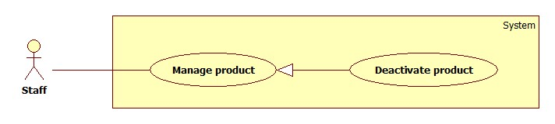

Figure … : <Staff> Deactivate Product

Use Case Specification

|  |  |  |  |
| --- | --- | --- | --- |
| **USE CASE –** | | | |
| **Use Case No.** |  | **Use Case Version** | 2.0 |
| **Use Case Name** | Deactivate Product | | |
| **Author** | Ha Chi Danh | | |
| **Date** | 30/05/2014 | **Priority** | Normal |
| **Actor:**   * Staff.   **Summary:**   * This use case allows staff to deactivate product.   **Goal:**   * Selected product will be deactivated.   **Triggers:**   * Staff wants to deactivate a product in the system. * To deactivate a product, staff must do the following steps:   + Choose “Quản lý sản phẩm” in sidebar menu.   + Click on “Không hoạt động” button.  **Preconditions:**   * User must log in the system with staff role. * There is at least one product activated in database.   **Post Conditions:**   * **Success**: Selected product will be deactivated. * **Fail:** Show error message.   **Main Success Scenario:**   |  |  |  | | --- | --- | --- | | Step | Actor Action | System Response | | 1 | Click “Quản lý sản phẩm” menu. | Navigate to “Quản lý sản phẩm” page which contains:   * A table has 6 columns:   + Số thứ tự.   + Mã Sản phẩm   + Tên sản phẩm.   + Tên Hãng.   + Chi tiết   + Trạng thái * A drop down list:   + Tìm kiếm bằng tên  + Tìm kiếm bằng hang   * Search: textbox * Tìm kiếm: button. | | 2 | Click on “không hoạt động” button. | Deactivate selected product. Show success message.  [Exception 1] |   **Alternative Scenario:**   |  |  |  | | --- | --- | --- | | Step | Actor Action | System Response | | 1 | Session time out | Display error message: “Bạn rời máy tính quá lâu, vui lòng đăng nhập lại để tiếp tục”.  Redirect to login page. |   **Exceptions:**   |  |  |  | | --- | --- | --- | | No | Actor Action | System Response | | 1 | Cannot deactivate product due to database connection problem | Show error message: “Thao tác thất bại. Vui lòng thử lại sau!” |   **Relationships: N/A**  **Business Rules:**   * Staff clicks “Không hoạt động” button. * Button is changed label from “Hoạt động” to ”Không hoạt động” and colour to red. | | | |

##### <Staff> Activate Product

Use Case Diagram

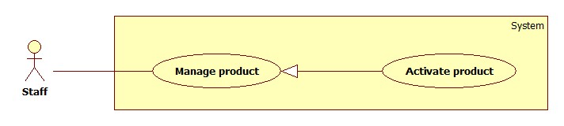

Figure … : <Staff> Activate Product

Use Case Specification

|  |  |  |  |
| --- | --- | --- | --- |
| **USE CASE –** | | | |
| **Use Case No.** |  | **Use Case Version** | 2.0 |
| **Use Case Name** | Activate Product | | |
| **Author** | Ha Chi Danh | | |
| **Date** | 30/05/2014 | **Priority** | Normal |
| **Actor:**   * Staff.   **Summary:**   * This use case allows staff to activate product.   **Goal:**   * Selected product will be activated.   **Triggers:**   * Staff wants to activate a product in the system. * To deactivate a product, staff must do the following steps:   + Choose “Quản lý sản phẩm” in sidebar menu.   + Click on “Hoạt động” button.  **Preconditions:**   * User must log in the system with staff role. * There is at least one product deactivated in database.   **Post Conditions:**   * **Success**: Selected product will be activated. * **Fail:** Show error message.   **Main Success Scenario:**   |  |  |  | | --- | --- | --- | | Step | Actor Action | System Response | | 1 | Clicks “Quan lý sản phẩm” menu. | Navigate to “Quản lý sản phẩm” page which contains:   * A table has 6 columns:   + Số thứ tự.   + Mã Sản phẩm   + Tên sản phẩm.   + Tên Hãng.   + Chi tiết   + Trạng thái * A drop down list:   + Tìm kiếm bằng tên.  + Tìm kiếm bằng hang.   * Search: textbox * Tìm kiếm: button | | 2 | Click on ‘hoạt động” button | Activate selected product. Show success message.  [Exception 1] |   **Alternative Scenario:**   |  |  |  | | --- | --- | --- | | No | Actor Action | System Response | | 1 | Session time out | Show error message: “Bạn rời máy tính quá lâu, vui lòng đăng nhập lại để tiếp tục”.  Redirect to login page. |   **Exceptions:**   |  |  |  | | --- | --- | --- | | No | Actor Action | System Response | | 1 | Cannot activate product due to database connection problem | Show error message: “Thao tác thất bại. Vui lòng thử lại sau!” |   **Relationships:** N/A  **Business Rules:**   * Staff clicks “Hoạt động” button. * Button is changed label from “Không hoạt động” to “Hoạt động” and colour to green. | | | |

1. **<Guest> Compare Product**

**Use case Diagram**

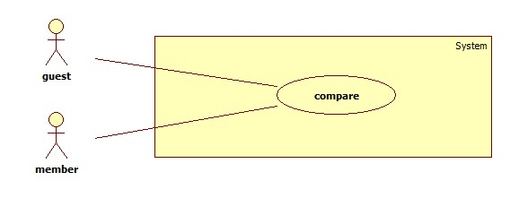

**Use case Diagram Specification**

|  |  |  |  |
| --- | --- | --- | --- |
| **USE CASE –** | | | |
| **Use Case No.** |  | **Use Case Version** | 2.0 |
| **Use Case Name** | Compare | | |
| **Author** | Ha Chi Danh | | |
| **Date** | 30/05/2014 | **Priority** | Normal |
| **Actor:**   * **Guest/member**   **Summary:**   * This use case allows guest/member to compare products on website.   **Goal:**   * Guest/member compares products in cart successfully.   **Triggers:**   * When cart has at least 2 products, Guest clicks “so sánh” button.   **Preconditions:**   * Cart must has at least 2 products.   **Post Conditions:**   * **Success**: Show comparison table with result of 2 or 3 products. * **Fail:** Show error message.   **Main Success Scenario:**   |  |  |  | | --- | --- | --- | | Step | Actor Action | System Response | | 1 | -Guest/member adds 2 or more products to cart  -Guest/member clicks “So sánh” button.  [Alternative 1,2,3] | Show comparison table. [exception 1] |   **Alternative Scenario:**     |  |  |  | | --- | --- | --- | | Step | Actor Action | System Response | | 1 | -Guest/member adds 1 product to cart  -Guest/member clicks “So sánh” button. | Show error message:”Phải có ít nhất 2 sản phẩm trong giỏ”. | |  | -Cart has no product.  -Guest/member clicks “so sánh” button | Show error message:”Phải có ít nhất 2 sản phẩm trong giỏ”. | | 2 | Session time out | Create new cart object in session.  Redirect to home page. |   **Exceptions:**   |  |  |  | | --- | --- | --- | | Step | Actor Action | System Response | | 1 | Cannot compare product due to database connection. | Show error message:”Thao tác thất bại, xin hãy thử lại”. |   **Relationships:** Add to cart  **Business Rules:** Guest/member clicks “So sánh” button, “So sánh” page will show in 2 situations:   * Situation 1: Result table of products in guest’s cart. * Situation 2: Error message :”Phải có ít nhất 2 sản phẩm trong giỏ” | | | |

1. **<Member> See suggestion**

**Use case Diagram**

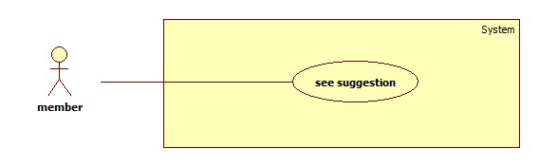

**Use case Diagram Specification**

|  |  |  |  |
| --- | --- | --- | --- |
| **USE CASE –** | | | |
| **Use Case No.** |  | **Use Case Version** | 2.0 |
| **Use Case Name** | See suggestion | | |
| **Author** | Ha Chi Danh | | |
| **Date** | 30/05/2014 | **Priority** | Normal |
| **Actor:**   * Member.   **Summary:**   * This use case allows member to see suggestion when comparing products on website.   **Goal:**   * Member sees suggestion when comparing products in cart successfully.   **Triggers:**   * When cart has at least 2 products, member clicks “so sánh” button.   **Preconditions:**   * User must login with member role.   **Post Conditions:**   * **Success**:   **+** Show comparison table products.  **+** Show points of product.  **+** Show recommend as list of products.   * **Fail:** Show error message.   **Main Success Scenario:**   |  |  |  | | --- | --- | --- | | Step | Actor Action | System Response | | 1 | * Member adds 2 or 3 products to cart * Member clicks “So sánh” button.   [Alternative 1,2,3] | Navigate to “So sánh” page with contains:   * Comparison table with information:   + Product which is winner and which is (are) runner-up in cart.  + Show Point of products.  + Show recommend as list of products.  [Exception 1] |   **Alternative Scenario:**   |  |  |  | | --- | --- | --- | | No | Actor Action | System Response | | 1 | * Cart has no product. * Member clicks “So sánh” button. | Show error message:” Phải có ít nhất 2 sản phẩm trong giỏ”. | | 2 | * Member adds 1 product to cart. * Member clicks “So sánh” button. | Show error message:” Phải có ít nhất 2 sản phẩm trong giỏ”. | | 3 | Session time out. | Show error message:”Vui lòng đăng nhập lại để được hỗ trợ nhiều hơn”.  Redirect to login page |     **Exceptions:**   |  |  |  | | --- | --- | --- | | No | Actor Action | System Response | | 1 | Cannot compare product due to database connection. | Show error message:”Thao tác thất bại, xin hãy thử lại”. |   **Relationships:** Add to cart  **Business Rules:**  Member adds 2 or 3 products to cart.  Member clicks “So sánh” button, “So sánh” page will show in 2 situations:   * Situation 1: Error message ”Phải có ít nhất 2 sản phẩm trong giỏ” * Situation 2:   + Show comparison table.  + Points of products.  + Show recommend as list of products that similar with products in member’s cart. | | | |

1. **<Authorized user>Log out**

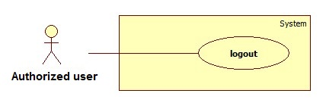

Figure: <Authorized user> Logout

Use Case Specification

|  |  |  |  |
| --- | --- | --- | --- |
| **USE CASE –** | | | |
| **Use Case No.** |  | **Use Case Version** | 2.0 |
| **Use Case Name** | Logout | | |
| **Author** | Ha Chi Danh | | |
| **Date** | 30/05/2014 | **Priority** | Normal |
| **Actor:**   * Authorized user.   **Summary:**   * This use case allows Authorized user to log out of the system.   **Goal:**   * Authorized user logs out of the system. Authorized user’s current session is destroyed.   **Triggers:**   * Authorized user wants to log out. * Authorized user clicks “Đăng xuất” link.   **Preconditions:**   * Authorized user has logged in to the system.   **Post Conditions:**   * **Success**: Authorized user’s current session is destroyed. Redirect to homepage. * **Fail:** Show error message.   **Main Success Scenario:**   |  |  |  | | --- | --- | --- | | Step | Actor Action | System Response | | 1 | Authorized user clicks “Thoát” link. | Show message “Bạn thực sự muốn thoát”   * Xác nhận: button * Hủy: button | | 2 | Authorized user clicks “Xác nhận” button. [Alternative 1] | Destroy Authorized user’s session. Redirect to homepage. [Exception 1] |   **Alternative Scenario:**   |  |  |  | | --- | --- | --- | | No | Actor Action | System Response | | 1 | Authorized user clicks “Hủy” button. | Do nothing. |   **Exceptions:**   |  |  |  | | --- | --- | --- | | No | Actor Action | System Response | | 1 | Fail to destroy Authorized user’s session | Redirect to error page. |   **Relationships:** N/a  **Business Rules:**   * Authorized user clicks “thoát” link, * Authorized user’s role will be changed to guest. | | | |

1. **<** **Authorized user> Change Password**

**Use case Diagram**

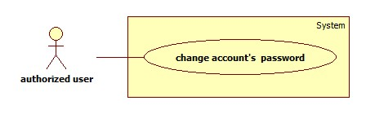

**Use case Diagram Specification**

|  |  |  |  |
| --- | --- | --- | --- |
| **USE CASE –** | | | |
| **Use Case No.** |  | **Use Case Version** | 2.0 |
| **Use Case Name** | Change account’s password | | |
| **Author** | Ha Chi Danh | | |
| **Date** | 30/05/2014 | **Priority** | Normal |
| **Actor:**   * Authorized user.   **Summary:**   * This use case allows Authorized user to change password.   **Goal:**   * Authorized user changes password successfully.   **Triggers:**   * Authorized user logins to website. * Authorized user clicks “Thay đổi mật khẩu” link.   **Preconditions:** Authorized user has register into the system.  **Post Conditions:**   * **Success:** New password has been updated into database. * **Fail:** Show error message.   **Main Success Scenario:**   |  |  |  | | --- | --- | --- | | Step | Actor Action | System Response | | 1 | Authorized user clicks “Thay đổi mật khẩu” link. | Show “Thay đổi mật khẩu ” page with includes:   * Mật khẩu cũ: textbox, password box, min length: 6, max length: 20, required. * Mật khẩu mới: textbox, password box, min length: 6, max length: 20, required. * Xác nhận mật khẩu mới: textbox, password box, min length: 6, max length: 20, required. * Thay đổi: button. * Xóa trắng: button. | |  | Authorized user clicks “Thay đổi” button [Alternative 1] | Show successful message and return to home page. [Exception 1,2, 3,4,5,6] |   **Alternative Scenario:**   |  |  |  | | --- | --- | --- | | No | Actor Action | System Response | | 1 | Authorized user clicks “Xóa trắng” button. | Clear all input fields. |   **Exceptions:**   |  |  |  | | --- | --- | --- | | No | Actor Action | System Response | | 1 | Length of password is not in range. | Show error message: “Độ dài mật khẩu phải từ 6-20 ký tự!” | | 2 | “Mật khẩu cũ” is wrong. | Show error message:”Sai mật khẩu.” | | 3 | “Mật khẩu cũ” is a blank. | Show error message:”Vui lòng nhập mật khẩu” | | 4 | “Mật khẩu mới” is a blank. | Show error message:”Vui lòng nhập mật khẩu mới” | | 5 | “Xác nhận mật khẩu mới” is a blank. | Show error message:”Vui lòng nhập xác nhận mật khẩu mới” | | 6 | “Mật khẩu mới” and “Xác nhận mật khẩu mới” is not similar. | Show error message: “Mật khẩu mới và Xác nhận mật khẩu mới không trùng khớp”. |   **Relationships:** N/A  **Business Rules:**   * Authorized user click “Thay đổi” button * New password has been updated into database. | | | |

1. **<Guest>Register**

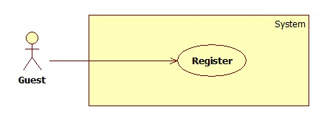

Figure: <Guest> Register

|  |  |  |  |
| --- | --- | --- | --- |
| **USE CASE –** | | | |
| **Use Case No.** |  | **Use Case Version** | 2.0 |
| **Use Case Name** | Register | | |
| **Author** | Ha Chi Danh | | |
| **Date** | 30/05/2014 | **Priority** | Normal |
| **Actor:**   * Guest.   **Summary:**   * This use case allows guest to register.   **Goal:**   * User can register new account to become a member of the system.   **Triggers:**   * Guest wants to be a member of the system. * To register, click “Đăng ký” link in menu bar.   **Preconditions:** N/A.  **Post Conditions:**   * **Success:** New member account is created. * **Fail:** Show error message.   **Main Success Scenario:**   |  |  |  | | --- | --- | --- | | Step | Actor Action | System Response | | 1 | Guest clicks “Đăng ký” link. | System show a register form which includes:   * Username: textbox, min length: 6, max length: 30, required. * Password: textbox, password box, min length: 6, max length: 20, required. * Đăng ký: button. * Xóa trắng: button. | | 2 | Guess enters required information, then clicks “Đăng ký” button. [Alternative 1] | Create new member account. Show success message.  [Exception 1,2, 3] |   **Alternative Scenario:**   |  |  |  | | --- | --- | --- | | No | Actor Action | System Response | | 1 | Guest clicks “Xóa trắng” button. | Clear all input fields. |   **Exceptions:**   |  |  |  | | --- | --- | --- | | No | Actor Action | System Response | | 1 | Length of username is not in range. | Show error message: “Độ dài username phải từ 6-30 ký tự!” | | 2 | Length of password is not in range. | Show error message: “Độ dài password phải từ 6-20 ký tự!” | | 3 | Username’s existed already. | Show error message: “Trùng tên đăng nhập! Vui lòng chọn tên khác!” |   **Relationships:** N/A  **Business Rules:**   * The role of new created account is “member”. | | | |

1. **<Guest> Log in**

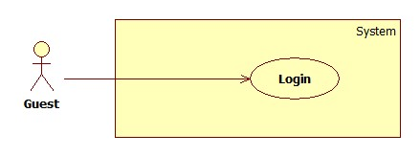

Figure: <Guest> Login

|  |  |  |  |
| --- | --- | --- | --- |
| **USE CASE –** | | | |
| **Use Case No.** |  | **Use Case Version** | 2.0 |
| **Use Case Name** | Login | | |
| **Author** | Ha Chi Danh | | |
| **Date** | 30/05/2014 | **Priority** | Normal |
| **Actor:**   * Guest.   **Summary:**   * This use case allows guest to login to the system.   **Goal:**   * Allow authentication and authorization of the system.   **Triggers:**   * Guest want to login into system. * To login: Guests go to the login link, enter username and password, and click “Đăng nhập” button to login.   **Preconditions:**   * Database has a registered account.   **Post Conditions:**   * **Success:** Guest is authorized, redirect to corresponding page. * **Fail:** System will show error on current page.   **Main Success Scenario:**   |  |  |  | | --- | --- | --- | | Step | Actor Action | System Response | | 1 | Guest goes to login page. | System show a login form, includes:   * Username: textbox, min length: 6, max length: 30, required. * Password: textbox, password box, min length: 6, max length: 20, required. * Đăng nhập: button. * Hủy: button * Create new account. | | 2 | Guess enter username and password into textboxes.  Press “Đăng nhập” button.[Alternative 1] | * Show message successful * “Ghi nhớ tài khoản”: check box   [Exception 1,2,3,4] |   **Alternative Scenario:**   |  |  |  | | --- | --- | --- | | No | Actor Action | System Response | | 1 | Press “Cancel” button. | Navigate to home page. |   **Exceptions:**   |  |  |  | | --- | --- | --- | | No | Actor Action | System Response | | 1 | “Tên tài khoản” is a blank | Show error message: “Vui lòng điền đủ username và password!” | | 2 | “Mật khẩu” is a blank | Show error message: “Vui lòng điền đủ username và password!” | | 3 | Username/Password not in range [5,30] | Show error message: “Thông tin không hợp lệ. Vui lòng thử lại!” | | 4 | Invalid “Username” and “Password” | Show error message: “Thông tin không hợp lệ. Vui lòng thử lại!” |   **Relationships:** N/A.  **Business Rules:**   * Each member, staff, admin has an account. * Only active account can log in. | | | |

1. **<Guest> View Detail**

**Use case Diagram**

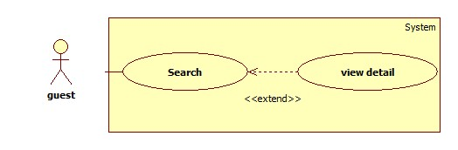

**Use case diagram specification**

|  |  |  |  |
| --- | --- | --- | --- |
| **USE CASE –** | | | |
| **Use Case No.** |  | **Use Case Version** | 2.0 |
| **Use Case Name** | View detail | | |
| **Author** | Ha Chi Danh | | |
| **Date** | 30/05/2014 | **Priority** | Normal |
| **Actor:**   * Guest.   **Summary:**   * This use case allows guest to search and view product information.   **Goal:**   * A page detail of products will be shown to guest.   **Triggers:**   * Guest inputs to a blank textbox then clicks “Tìm kiếm” button. * Guest inputs URL of product or serial number then they search all products with relative URL or serial number which they inputted. The searching results will show product detail.   **Preconditions:** N/A  **Post Conditions:**   * **Success**: Show search results as a page of product with URL or serial number that guest inputted * **Fail:** Show an error message.   **Main Success Scenario:**   |  |  |  | | --- | --- | --- | | Step | Actor Action | System Response | | 1 | Guest inputs the product’s URL or serial number into textbox. | Show “Search” page with includes:   * Tìm bằng đường dẫn/ tìm bằng số seri: drop down list. * Search: textbox * Tìm kiếm: button | | 2 | Guest clicks “Tìm kiếm” button. | * System will show page detail product by product URL or serial number.[Exception1] |   **Alternative Scenario:** N/A  **Exceptions:**   |  |  |  | | --- | --- | --- | | Step | Actor Action | System Response | | 1 | Search not found | Redirect to Not found page.  Show message:”Vui lòng đăng nhập để được hỗ trợ nhiều hơn”. |   **Relationships:** Search  **Business Rules:**   * User search by URL or serial number of product * System will search all products in database. * If that product is existed, system will show detail page of that product. | | | |

1. **<Member> View Detail**

**Use case Diagram**

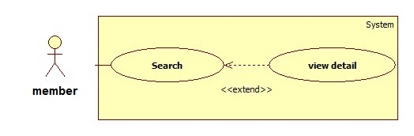

**Use case diagram specification**

|  |  |  |  |
| --- | --- | --- | --- |
| **USE CASE –** | | | |
| **Use Case No.** |  | **Use Case Version** | 2.0 |
| **Use Case Name** | View detail | | |
| **Author** | Ha Chi Danh | | |
| **Date** | 30/05/2014 | **Priority** | Normal |
| **Actor:**   * Member.   **Summary:**   * This use case allows member to search and view product information.   **Goal:**   * A page detail of products will be shown to member.   **Triggers:**   * Member inputs to a blank textbox then clicks “Tìm kiếm” button. * Member inputs URL of product or serial number then they search all products with relative URL or serial number which they inputted. The searching results will show product detail.   **Preconditions:** N/A  **Post Conditions:**   * **Success**: Show search results as a page of product with URL or serial number that user inputted * **Fail:** Show an error message.   **Main Success Scenario:**   |  |  |  | | --- | --- | --- | | Step | Actor Action | System Response | | 1 | Member inputs the product’s URL or serial number into textbox. | Show “Search” page with includes:   * Tìm bằng đường dẫn/ tìm bằng số seri: drop down list * Search: textbox * Tìm kiếm: button | | 2 | User clicks “Tìm kiếm” button.  [Alternative 1] | * System will show page detail product by product URL or serial number. * Rating: icon. * Thêm vào giỏ: button   [Exception 1] |   **Alternative Scenario:**   |  |  |  | | --- | --- | --- | | Step | Actor Action | System Response | | 1 | Session time out. | Show message:”bạn rời máy tính quá lâu, vui lòng đăng nhập lại để tiếp tục”  Redirect to login page. |   **Exceptions:**   |  |  |  | | --- | --- | --- | | Step | Actor Action | System Response | | 1 | Search not found | Redirect to Recommend Page |   **Relationships:** Search.  **Business Rules:**   * User search by URL or serial number of product * System will search all products in database. * If that product is existed, system will show detail page of that product. * If that one is not existed, system will navigate to recommend page. | | | |

1. **<System> Send notification**

**Use case Diagram**

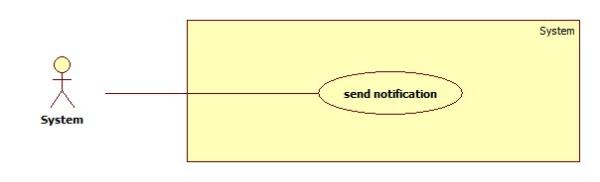

**Use case Diagram Specification**

|  |  |  |  |
| --- | --- | --- | --- |
| **USE CASE – 13** | | | |
| **Use Case No.** | 13 | **Use Case Version** | 2.0 |
| **Use Case Name** | send notification | | |
| **Author** | Ha Chi Danh | | |
| **Date** | 30/05/2014 | **Priority** | Normal |
| **Actor:**   * System.   **Summary:**   * This use case describes how system sends notification to member.   **Goal:**   * System sends notification to member successfully.   **Triggers:**   * Member clicks on “Thông báo” link to get notification.   **Precondition:**   * Member proposes to system.   **Post Conditions:**   * **Success**: Show notification as message when member click on “Thông báo” link. * **Fail:**   + Member’s session is time out.  + System will show message on member’s screen:“Bạn rời máy tính quá lâu, xin vui lòng đăng nhập lại để tiếp tục”.  + Redirect to home page.  **Main Success Scenario:**   |  |  |  | | --- | --- | --- | | Step | Actor Action | System Response | | 1 | * System compares the newest record has just been inserted into table Product with all records of table Recommend Product in database. |  | | 2 | * If it is similar with any records of table Recommend Product, System will change column status of correlative records from “IsActive” to “Deactivate” in table Recommend Product. | * Show message:”Chúng tôi mới bổ sung một số sản phẩm mới, có thể có những sản phẩm trước đây bạn tìm nhưng không có, bạn có thể kiểm tra lại.”   [Exception 1] | | 3 | * It is not similar with any records of table Recommend Product | * Do nothing. |   **Alternative Scenario:**  N/A  **Exceptions:**   |  |  |  | | --- | --- | --- | | Step | Actor Action | System Response | | 1 | Member’s session is time out | * Show message error on member’s screen:”Bạn rời máy tính quá lâu, xin vui lòng đăng nhập lại để tiếp tục”. * Redirect to home page. |     **Relationships: N/A**.  **Business Rules:**   * System compares the newest record has just been inserted into table Product with all records of table Recommend Product in database. * If it is similar with any records of table Recommend Product, System changes status of correlative records in table RecommedProduct from “isActive” to “Deactivate”, tracking time in system and Notification will be sent to member. * Member clicks on “Thông báo” link, Content of notification will be shown. | | | |